

CHETWYNDE SCHOOL

CAREERS POLICY

2023

Approved by¹
Name: | Mr John Burgess
Position: | Chair of Governors
Signed: | 
Date: | January 2023
Proposed Review Date² | January 2024

Contents

- Statutory Duty
- Statement of Intent / Objectives
- Roles and Responsibilities
- Implementation of the career plan
- Measuring the impact of CEIAG

Statutory duty
Chetwynde School has a statutory duty to provide independent careers information and guidance for all pupils from year 7 to 11 (The Education Act 2011 / Careers guidance and access for education and training providers July 2021). The policy is supported by a Career Plan with planned support for all pupils regardless of their race, sex or academic abilities need a planned programme of activities to help them make decisions and plan their careers.
Chetwynde School is required to meet the eight Gatsby Benchmarks for Good Career Guidance. From September 2013 The Education Act of 2011 placed schools under a duty to ensure that all registered pupils in Years 8-11 have access to independent, accurate and impartial information advice and guidance.

Statement of intention and objectives
Careers Education, Information, Advice and Guidance (CEIAG) will be presented without bias and be will be impartial. Careers guidance will include a range of education or training options, including T levels, apprenticeships and other vocational pathways

The best interests of the pupils will be the focus for all information and guidance. We recognise that progression planning has a vital role in maximising the future well being of a young person and the local community. The school values of respect, responsibility and resilience will be embedded within careers guidance.

The delivery of a successful careers plan will mean that pupils make confident and informed choices. By making robust plans pupils will be motivated work hard to complete planned actions for successful progression.
We will support pupils in making well-informed decisions by providing access to differentiated, impartial, independent information and guidance about a wide range of options. Their decision making will be supported by learning about the local labour market. Pupils will be challenged to have high expectations and to be aspirational in their plans. Pupils will learn that career development is life long and resilience will involve making changes to their plans when the need arises.

Pupils will learn about a wide range of careers and stereotypes will be challenged. Weekly senior school assemblies will be key events for showcasing the breadth of career options.

During their time at school learners will:
- Understand themselves, their interests, likes and dislikes, what they are good at and how this affects the choices they make.
- Find out about different courses, what qualifications they might need and what opportunities there might be.
- Develop a range of skills for working life
- Make realistic, but ambitious choices about courses and jobs.
- Be able to make effective applications for jobs, training and further and higher education.
- Develop interview skills
- Increase in confidence
- Receive high quality information, advice and guidance from suitably qualified staff.

Objectives:
- To support pupils to be self-aware; by understanding their preferences, skills and talents pupils can make better choices
- To give pupils the opportunity to develop employability skills and attitudes
- To make pupils aware of the breadth of opportunities available to them post 16+
- To provide IAG about option choices in year 9 and how they relate to post 16 progression
- To engage with parents as pupils make choices about progression plans
- To provide appropriate up-to-date and accurate information
- To make forge positive links with local businesses and further/higher education establishments.
- To enable students to experience the world of work and develop transferable skills.
- To ensure that, all young pupils leave Chetwynde School to embark on suitable employment, education or training.
- To promote equality of opportunity, celebrate diversity, challenge stereotypes and ensure all students who require any extra assistance and guidance to reach their potential, such as SEN students or pupil premium students receive it.
- To give information on the range of education or training options, including apprenticeships and technical education routes.
- To ensure that there is an opportunity for a range of education and training providers to access all pupils in Year 7 to Year 11 for the purpose of informing them about technical education qualifications or apprenticeships.
- To develop students’ skills and knowledge of careers including career management skills and knowledge of the local labour market
- To be weaved and embedded into subjects across the Curriculum.
- To be based on the Gatsby Benchmarks for Good Career Guidance

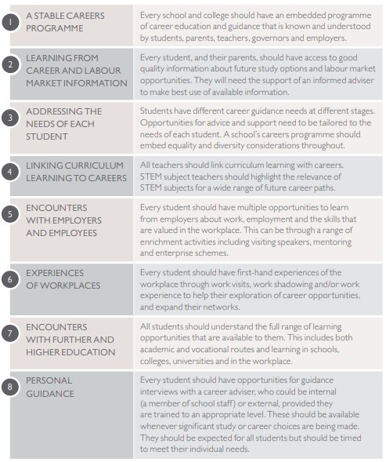

Roles and responsibilities

Form teachers are key in supporting pupils to make informed choices that suit their preferences and unique abilities.

The careers lead will support form teachers and PHSE teachers for the delivery of effective CEIAG.

The careers lead will update the senior management team about progress with the careers plan at weekly management meetings

Governors will be updated CEIAG activities at each LGB meeting

Implementation of the Career Plan

Pupils most at risk of becoming NEET (Not in Employment Education of Training) are identified, targeted and prioritised when scheduling one to one careers interviews.
The Local Authority provides careers interviews for the most vulnerable Year 11 pupils through a service-level agreement
The scheme of learning for PSHE support the delivery of CEIAG that has equal opportunities as a core value.

Positive partnerships with local providers are vital for good CEIAG. We seek to nurture positive links with employers and education providers. This involvement includes the provision of work experience placements, careers talks, and workplace visits. Links are also maintained with various training providers supporting apprenticeships for those pupils considering that route as an alternative to further or higher education.

Parents and carers are the biggest influencers on a young person’s career choices and we offer parents help and guidance at critical stages in the pupils learning journey. Key information events for parents take place in Year 9 with KS4 options decisions, Year 10 with Work Experience placements and Year 11 with 16+ choices.

The school has strong links to local Employers
- BAE
- Cumbria County Council
- Inspira
- Gen 2
- GlaxoSmithKline
NHS
- Oxley
- Sellafield
- Siemens

Chetwydne School aims to host an annual careers fair for key stage 4 pupils and parents.

We have links to the following local education providers:
• Furness College (including Barrow sixth form)
- UVHS
- Kendal College
- Lancaster and Morecambe College
- Russel Group Universities
- UCLAN (University of Central Lancashire)
- Oxford University

Staff Development needs are identified through performance management, staff appraisals and line manager meetings . CPD is offered to relevant staff as opportunities arise. The Careers Lead attends local and regional careers network meetings to share good practice with other local secondary schools and careers providers.

The Careers Plan is published on the school websites and is updated frequently.

Measuring the impact of CEIAG

Regular monitoring and evaluation take place to inform future planning and identify current needs. Tracking is supported by the use of Compass ++ .

Monitoring activities used to ensure that the careers programme is being implemented as planned include:
- Learning walks
- Careers booklet checks
- Lesson observations
- Questionnaires – students, staff, parents and carers, external partners
- Collection of destination data

Evaluation activities include:
- Analysis of destination data
- Analysis of data from questionnaires – students, staff, parents and carers, external partners
- Student learner experience groups

The effectiveness of our CEIAG will be evident in the quality of destinations achieved by pupils leaving school after Year 11. Destination data (Dfe) is used to assess how successfully students make the transition into the next stage of education or training, or into employment and to inform future careers provision.

